**Code for Chapter 5**

**Example 5.2**

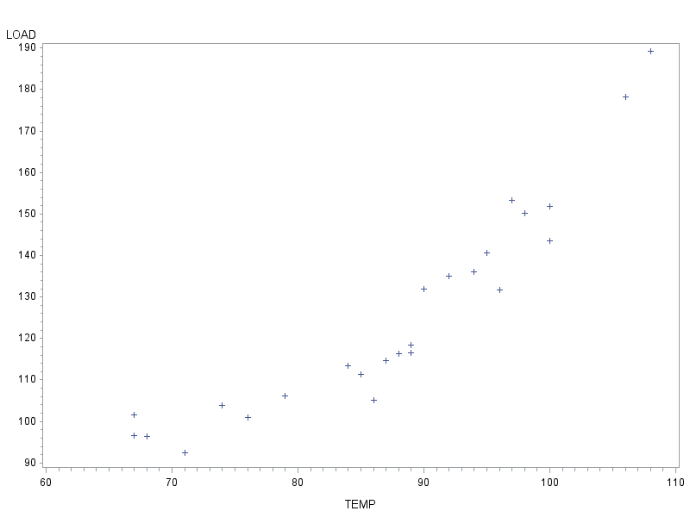

***For 3rd order model: E(y)* = *β*0 + *β*1*x* + *β*2*x*2 + *β*3*x*3**

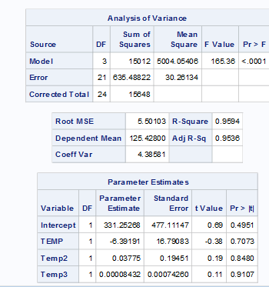

***For 2nd order model: E(y)* = *β*0 + *β*1*x* + *β*2*x*2**

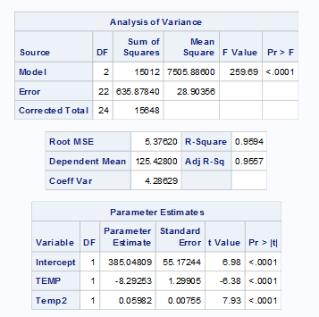

**data** Powerload;

infile 'C:\Users\yusha\Desktop\TEACHING\stat2223\my own\Text\Text\Exercises&Examples\POWERLOADS.txt' dlm='09'x firstobs=**2**;

input TEMP LOAD;

**run**;

**proc** **print** data=powerload (obs=**3**);

**run**;

**proc** **gplot** data=powerload; /*scatter plot*/

plot Load*Temp;

**run**;

/* In order to fit higher order model, we need firstly to create Temp^2 and Temp^3, as shown below*/

**data** powerload1;

set powerload;

Temp2=Temp\*\***2**;/*temp raise power 2*/

Temp3=Temp\*\***3**; /*temp raise power 3*/

**run**;

**proc** **print** data=powerload1 (obs=**3**);

**run**;

/* Now it is ready to run the regression, regarding temp2 and temp3 as new independent variables*/

**proc** **reg** data=powerload1;

model Load=temp temp2 temp3;

model Load=temp temp2;

title 'Regression For Powerload'; **run**;

**Example 5.3**

**For full model:**

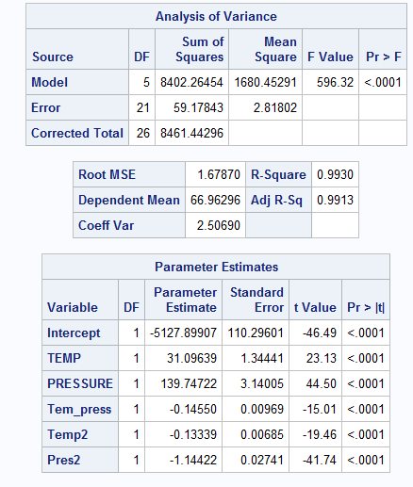

**For reduced model**

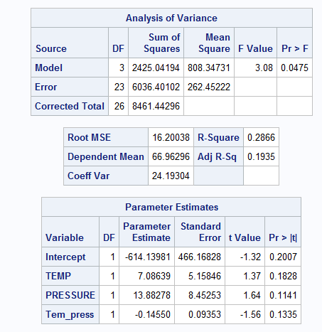

**data** Prodqual;

input TEMP PRESSURE QUALITY;

datalines;

80 50 50.8

80 50 50.7

80 50 49.4

80 55 93.7

80 55 90.9

80 55 90.9

80 60 74.5

80 60 73.0

80 60 71.2

90 50 63.4

90 50 61.6

90 50 63.4

90 55 93.8

90 55 92.1

90 55 97.4

90 60 70.9

90 60 68.8

90 60 71.3

100 50 46.6

100 50 49.1

100 50 46.4

100 55 69.8

100 55 72.5

100 55 73.2

100 60 38.7

100 60 42.5

100 60 41.4

;

**run**;

**proc** **print** data=Prodqual (obs=**3**);

**run**;

/* In order to fit higher order model, we need firstly to create all other variables, as shown below*/

**data** prodqual1;

set prodqual;

Temp2=Temp\*\***2**;

Pres2=PRESSURE\*\***2**;

Tem_press=Temp*Pressure;

**run**;

**proc** **print** data=prodqual1 (obs=**3**);

**run**;

/* Now it is ready to run the regression*/

**proc** **reg** data=prodqual1;

model QUALITY=temp Pressure tem_press temp2 pres2; /*full model*/

title 'Regression For Product Quality';

**run**;

**proc** **reg** data=prodqual1;

model QUALITY=temp Pressure tem_press; /*reduced model*/

title 'Regression For Product Quality';

**run**;

**Example 5.5**

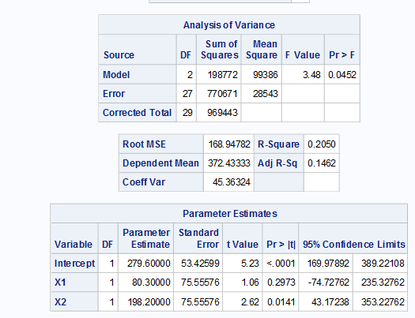

**data** bidmaint;

input STATE $ COST X1 X2;

datalines;

Kansas 198 0 0

Kansas 126 0 0

Kansas 443 0 0

Kansas 570 0 0

Kansas 286 0 0

Kansas 184 0 0

Kansas 105 0 0

Kansas 216 0 0

Kansas 465 0 0

Kansas 203 0 0

Kentucky 563 1 0

Kentucky 314 1 0

Kentucky 483 1 0

Kentucky 144 1 0

Kentucky 585 1 0

Kentucky 377 1 0

Kentucky 264 1 0

Kentucky 185 1 0

Kentucky 330 1 0

Kentucky 354 1 0

Texas 385 0 1

Texas 693 0 1

Texas 266 0 1

Texas 586 0 1

Texas 178 0 1

Texas 773 0 1

Texas 308 0 1

Texas 430 0 1

Texas 644 0 1

Texas 515 0 1

;

**run**;

**proc** **print** data=bidmaint (obs=**3**);

**run**;

**proc** **reg** data=bidmaint alpha=**0.05**;

model cost =X1 X2/clb;

title 'Regression about Annual Maintainance Cost';

**run**;

**Example 5.10**

**Main effect model**

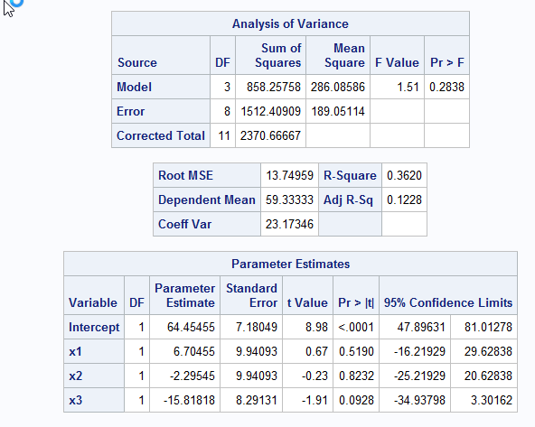

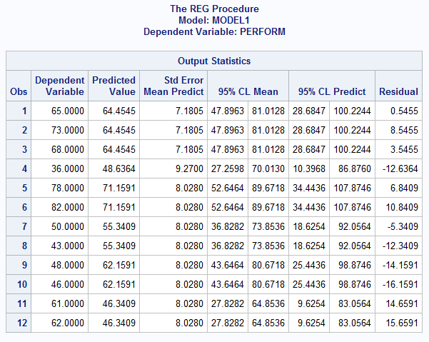

**Interaction model**

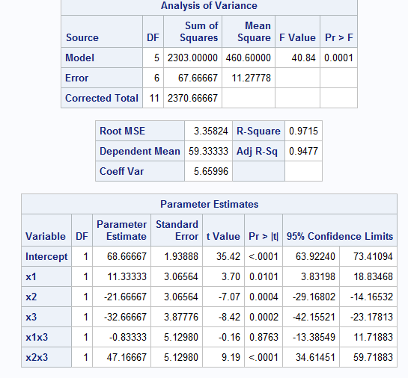

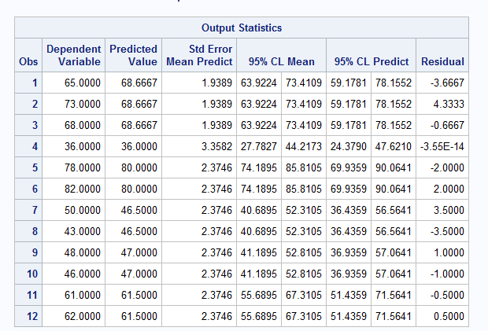

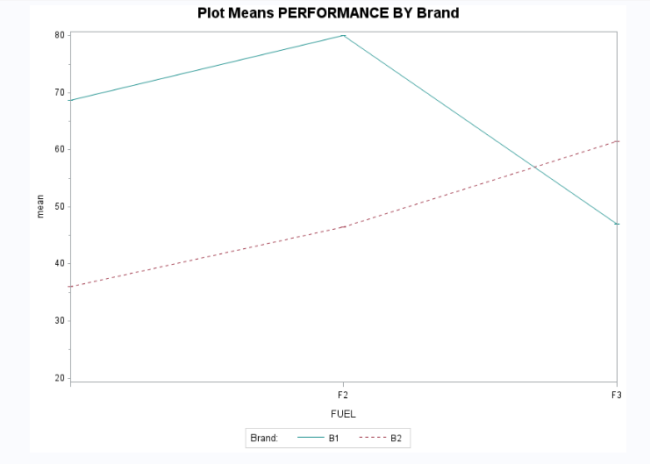

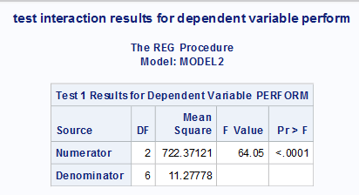

**data** diesel;

input FUELBRAND $ PERFORM FUEL$ BRAND$;

datalines;

F1B1 65 F1 B1

F1B1 73 F1 B1

F1B1 68 F1 B1

F1B2 36 F1 B2

F2B1 78 F2 B1

F2B1 82 F2 B1

F2B2 50 F2 B2

F2B2 43 F2 B2

F3B1 48 F3 B1

F3B1 46 F3 B1

F3B2 61 F3 B2

F3B2 62 F3 B2

;

**run**;

**proc** **print** data=diesel (obs=**3**);

**run**;

**DATA** diesel1 ; /* Create Dummy Variables*/

SET diesel ;

IF FUEL = 'F2' THEN x1 = **1**;

ELSE x1 = **0**;

IF FUEL = 'F3' THEN x2 = **1**;

ELSE x2 = **0**;

if Brand='B2' then x3=**1**;

else x3=**0**;

x1x3=x1*x3;

x2x3=x2*x3;

**RUN**;

**proc** **reg** data=diesel1;

model perform= x1 x2 x3/CLB CLI CLM ALPHA=**0.05**; /*main effect model*/

model perform= x1 x2 x3 x1x3 x2x3/CLB CLI CLM ALPHA=**0.05**; /*interaction model*/

title 'Regression for Engine Performance';

test x1x3=x2x3=**0**;/*partial F-test for above nested model*/

title 'test interaction results for dependent variable perform';

**run**;

**/* the following codes are for plotting mean performance for different brand at each fuel type for observation data*/**

**proc** **sort** data=diesel;

by FUEL BRAND;

**run**;

/* Calculate the mean and standard error for each X */

**proc** **means** data=diesel;

by FUEL BRAND;

var PERFORM;

output out=meansout(drop=_type_ _freq_) mean=mean;

**run**;

**data** reshape(keep=FUEL BRAND PERFORM mean);

set meansout;

by FUEL BRAND;

**run**;

/* Define the title */

title1 'Plot Means PERFORMANCE BY Brand';

/* Define the axis characteristics */

axis1 offset=(**0**,**0**) minor=none value=(t=**1** ' ' t=**7** ' ');

axis2 label=(angle=**90**) order=(**20** to **80** by **10**) minor=(n=**1**);

/* Define the symbol characteristics */

symbol1 interpol=hiloctj color=vibg line=**1**;

symbol2 interpol=hiloctj color=depk line=**2**;

/* Define the legend characteristics */

legend1 label=('Brand:') frame;

/* Plot the error bars using the HILOCTJ interpolation */

/* and overlay symbols at the means. */

**proc** **gplot** data=reshape;

plot mean*FUEL=BRAND / haxis=axis1 vaxis=axis2 legend=legend1;

**run**;

**quit**;